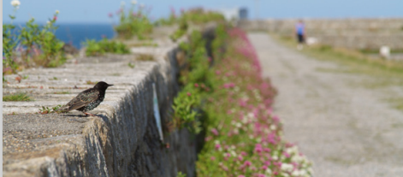

Research Title
Societal perceptions of informal wild spaces in cities

Research Team
Principal Researcher: Dr. Marcus Collier, Trinity College Dublin

Research Funding
This research is fully funded by the European Research Council grant agreement No 101002440)

What is NovelEco?
Cities contain many informal wild spaces or ‘urban novel ecosystems’ of different shapes and sizes’ spaces that, in urban areas, are not normally found in ecosystems outside cities. An informal wild space can be anywhere. They can be unused land, or a unmanaged corner of a street; they can be a collection of wild plants growing along the top or bottom of a wall, or an overgrown derelict site; they can be a sudden flush of wildflowers at the side of the road, or a steep slope or rock area that is too difficult to manage. In other words, informal wild spaces can be almost anywhere, almost any size, and almost any shape. It is only when we notice them that we start to give them values. But, what are these values? Little is known about them because many people ignore or avoid wild spaces in cities. NovelEco wants to involve citizens in collecting ecological data on informal wild spaces. This is what we are looking to find and it is why we need citizens to be our eyes ‘on the ground’, so to speak. This survey is aimed on gathering information that will help us to design our research approach and answer the questions you would like to know the answer to.

Why should I participate?
This survey is designed to capture information about your personal perceptions and values of informal wild spaces in cities. We are seeking to hear your experiences and perceptions of these spaces, and the findings will build a picture of our relationship with wild spaces and help scientists and communities to rewild our cities. We would welcome your participation in this short, anonymous survey.
Who will see my answers?
We assure you that this is a strictly confidential survey, and responses are anonymous. All data collected through this survey will be held securely and confidentially in accordance with the General Data Protection Regulation 2018 and the Data Protection Act 2018. Under no circumstances will your individual responses be made available to anyone outside the research team. Individual results will be aggregated anonymously, and research reported on aggregate or combined results. At no point will the information you provide be shared in a way that would allow you to be personally identified. Any published material will be anonymised. More information, including a full data protection and confidentiality statement, can be found here.
Will I be asked to provide personal details?
By taking part in this survey, you will be asked to provide the following information:
- Your full name, gender (M/F/X), date of birth, nationality, and country of residence. This is for statistical purposes only.
Your personal data will be collected and processed by our research team. The data you provide by compiling and signing this Informed Consent will be gathered on computer files not stored in the ‘cloud’, and accessed only by our researchers. Unauthorised access is prevented by the adoption of the following security measures: we will employ a password to get access to computer files storing your personal data (using a double authentication process). Your data on this computer is encrypted through available encryption software. These data will not be shared in any case with, or disclosed to, anyone outside our research team.
How long will it take?
The survey will take about _______ minutes to complete.
Who should I contact?
If you have any queries regarding this survey, please contact info@noveleco.eu
Thank you.

Professor Marcus Collier, School of Natural Sciences, Trinity College, Dublin.

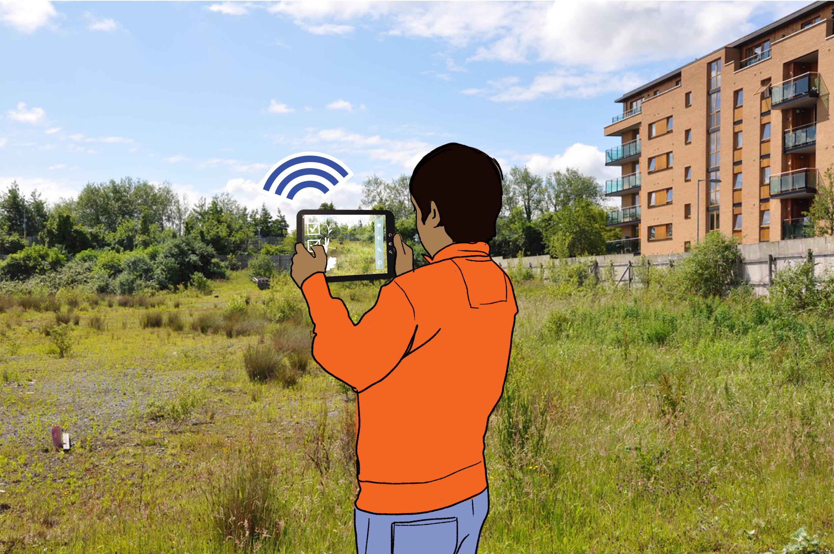
PARTICIPANT CONSENT FORM
I, the undersigned, confirm that (please tick the box):
1 | I am 18 years or older and I voluntarily consent to participate in this study.
2 | I confirm I have read, or had read to me, and have understood the information on this survey.
3 | The information has been fully explained to me and I have been able to ask questions, all of which have been answered to my satisfaction.
4 | I voluntarily agree to participate in the project. I am fully aware that I am not obliged to answer any questions, but that I do so at my own free will.
5 | I understand that if I decide at any time during the interview that I no longer wish to participate in this project, I can notify the researcher involved and withdraw from it immediately without giving any reason. Furthermore, I understand that I will be able to withdraw my data up to one month after the interview.
6 | I consent to the use of anonymised direct quotes of my words from the interview in publicly available study reports.
7 | I consent to the digital audio-recording / online video recording of my interview.
8 | I understand the principles of confidentiality, anonymity, and storage of data according to the Trinity College Dublin data management policy.
9 | I understand that any identifiable information about me (personal data), including the transfer of this personal information about me outside of the EU, will be protected in accordance with the General Data Protection Regulation (GDPR).
10 | I agree that information of the participant’s identity to be coded using an assigned ID for purposes of confidentiality
11 | The use of the data in research, academic publications, sharing and archiving has been explained to me.
12 | I understand that other researchers will have access to this data only if they agree to preserve the confidentiality of the data and if they agree to the terms I have specified in this form.
13 | I am also aware that this project has been reviewed by, and received ethics clearance through, the Research Ethics Committee at Trinity College Dublin. I was informed that if I have any comments or concerns resulting from my participation in this study, I may contact the TCD Research Ethics Officer.
14 | I, along with the Researcher, agree to sign and date this informed consent form.
15 | I will be given a copy of this consent form.
16 | I consent to be photographed and will be asked for additional consent if my image will be used in public activities
I have confirmed all 16 of the statements above.

_____________________________ _______________________
Signature of participant date

I certify that I have presented the above information to the participant.

_____________________________ _______________________
Signature of Researcher date

